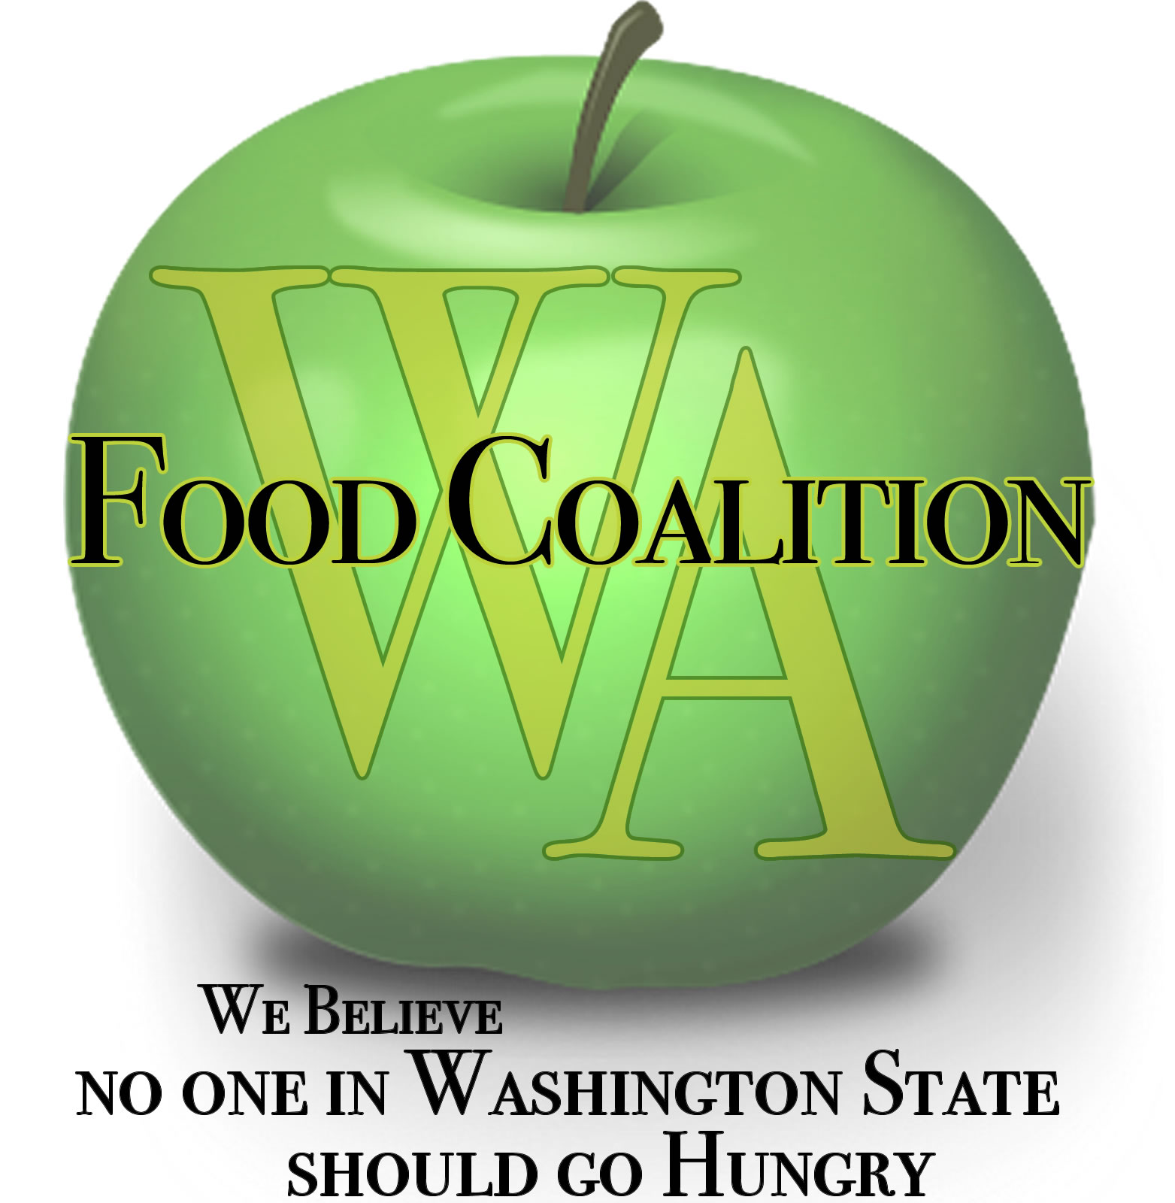
Washington Food Coalition
www.wafoodcoalition.org
PO Box 95752
Seattle, WA 98145
phone: 206.729.0501
fax: 206.729.0504
info@wafoodcoalition.org

Food Assistance Advisory Committee Mtg
April 15, 2021 9:00am-10:30am

Please join my meeting from your computer, tablet or smartphone.
https://global.gotomeeting.com/join/420851413

You can also dial in using your phone.
United States: +1 (646) 749-3122
Access Code: 420-851-413

AGENDA

9:00 Welcome

9:05 Volunteer Secretary Needed

9:10 Approval of Minutes from February 2nd Meeting

9:20 WSDA Updates – Kim
- Capacity Grants Awards
- CFAP Boxes Update
- EFAP Biennium funding
9:50 Review work in progress
- Subcontractor Resources Task Force on hold, WFC working on resources for the future:
  - Upcoming WFC trainings: Food Bank Certification Course – May date(s) TBD, Food Safety Training with Susan Shelton, Workplace Safety Training(s) this Spring.

9:55 Discussion topics:
- TEFAP Update & Discussion
  - TEFAP Overall – How is it going?
  - TEFAP boxes update, clarity on terms
  - TEFAP products
  - How are you adding additional TEFAP site?
- In-take Requirements Subcommittee report out
- Statewide Nutrition Policy – Create sub-group.
10:25 Good of the Order?

10:30 Close

