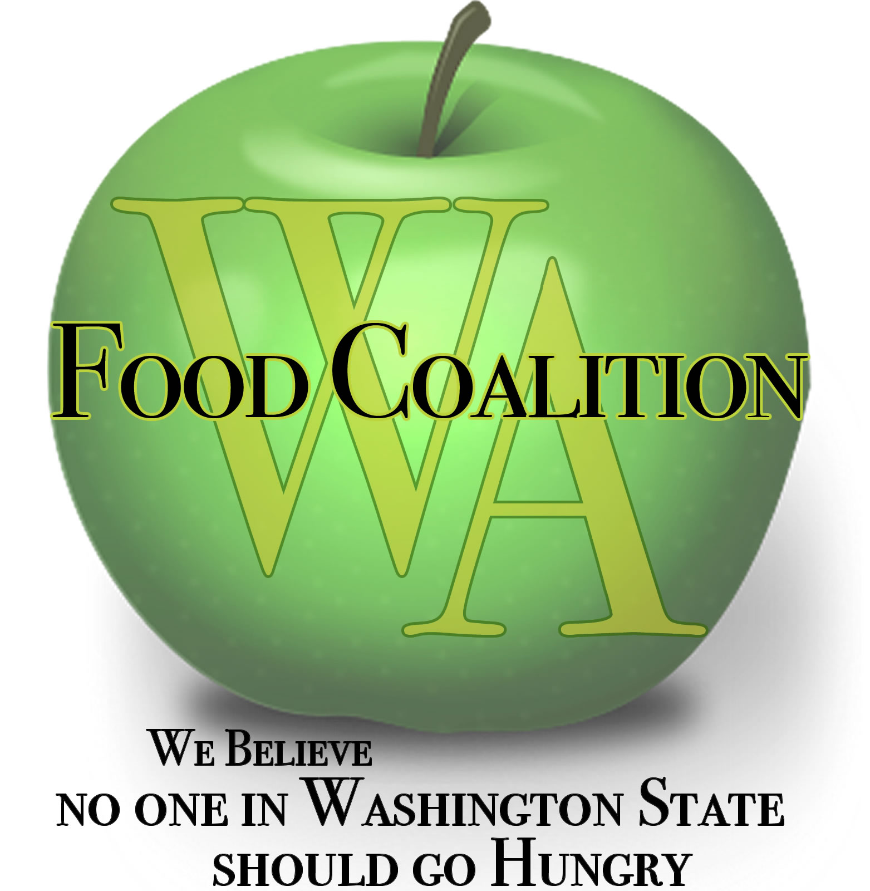
Washington Food Coalition
www.wafoodcoalition.org
PO Box 95752
Seattle, WA 98145
phone: 206.729.0501
fax: 206.729.0504
info@wafoodcoalition.org

Food Assistance Advisory Committee Mtg
August 24, 2021 1 -2:30 p.m.

AGENDA

1:00 Welcome / Introductions – Be camera ready! Changes due to Delta variant increase?

1:15 Approval of Minutes from June 17th Meeting

1:20 WSDA Updates – Kim Eads
- Supplemental Grants Update
  - Pending Capacity Needs Assessment with UW and HAH
- Flexible Funding Grants sub-committee
- Feedback on WSDA Conference Session Topics
- General funding update
- Fresh Boxes – WSDA Food Assistance Fresh Boxes, TEFAP & CFAP Alternative
- TEFAP Risk Assessment
- TEFAP Supply Chain Issues
1:50 Review work in progress:
- Subcontractor Resources Task Force - on hold
- Statewide Nutrition Policy – Kate /Trish
- Ad Hoc Committee on Grant Process - Read attached report
- Capacity Grant Improvement Survey report – Read attached report
- Harvest Against Hunger Update

2:05 Discussion topics:
- In-take Requirements Subcommittee Report out – Michelle
  - Initial response to remove the collection of addresses for TEFAP
- What do people need going forward?
  - Smoke and Heat Policies – How are you handling it?
  - PPE?
- WFC Conference updates, September 29th – October 1st, 2021
2:25 Good of the Order: Contractor Calls - Next call: this Friday, August 20th
then again on September 17th
Contractor calls are meeting one a month.
General Focus Calls – Next call: September 7th, 9 a.m.
General Focus calls are meeting one a month.
WFC Board Meeting – September 29th at 10:30 a.m.
2:30 Close

