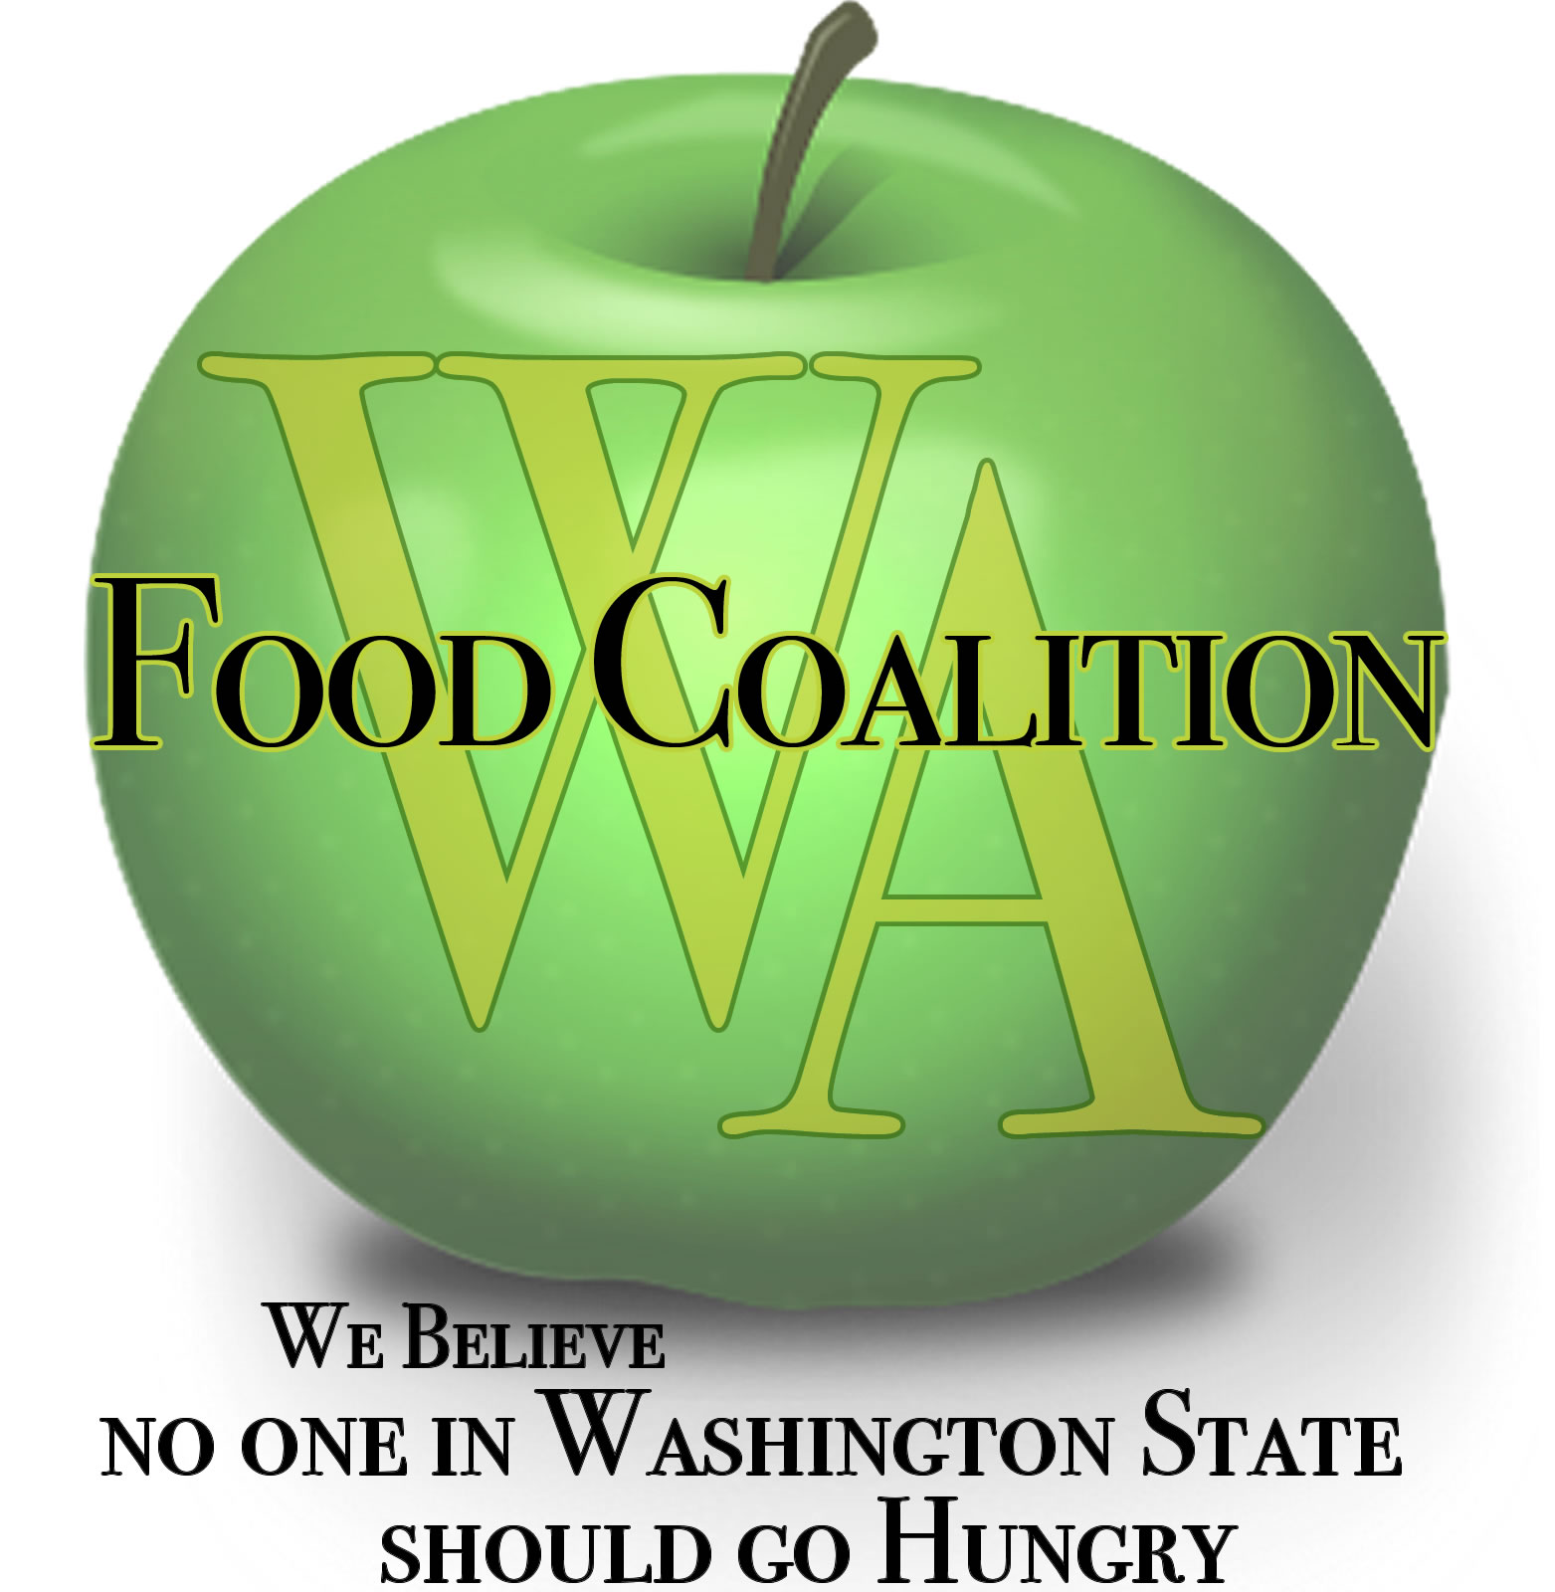
Washington Food Coalition
www.wafoodcoalition.org
PO Box 95752
Seattle, WA 98145
phone: 206.729.0501
fax: 206.729.0504
info@wafoodcoalition.org

Food Assistance Advisory Committee Mtg
January 24, 2020 9:00am-10:30am

Location:
Thurston County Food Bank Warehouse & Distribution Center,
2260 Mottman Rd SW, Tumwater, WA 98512, USA (map)
Please join my meeting from your computer, tablet or smartphone.
https://global.gotomeeting.com/join/179636837
You can also dial in using your phone.
United States: +1 (646) 749-3122 Access Code: 179-636-837
Joining from a video-conferencing room or system? Depending on your device,
dial directly: 179636837@67.217.95.2 or 67.217.95.2##179636837
New to GoToMeeting? Get the app now: https://global.gotomeeting.com/install/152548389

AGENDA

9:00 Welcome and Intros

9:05 Approval of Minutes from September 23rd Meeting

9:10 Review work in progress
Civil Rights Task Force update (5 min.)
Subcontractor Resources Task Force update (5 min.)
Food Procurement Policy update and discussion (30 min.)

9:40 WSDA Updates

10:05 Legislative Updates

10:15 Discussion topics
Inventory Management – TMP/TEFAP – Best Practices

10:25 News for the Good of the Order?

10:30 Close

NEXT MEETINGS – TBD

NOTE: To participate in the WFC Board meeting you will need to use GOTO meeting from the Board agenda.

